**FRIMPO RESEARCH & EXECUTION**

I started with the idea that I wanted to to make a vive accessory, using the vive tracker. I next wanted to make it interesting to hold, rather than just make another hard plastic object like all the other VR accessories coming out. This lead me to think up a hairy, jelly creature that would react to how you played with it. This then lead me to toys like Furby, Furreal Pets and Webkinz.

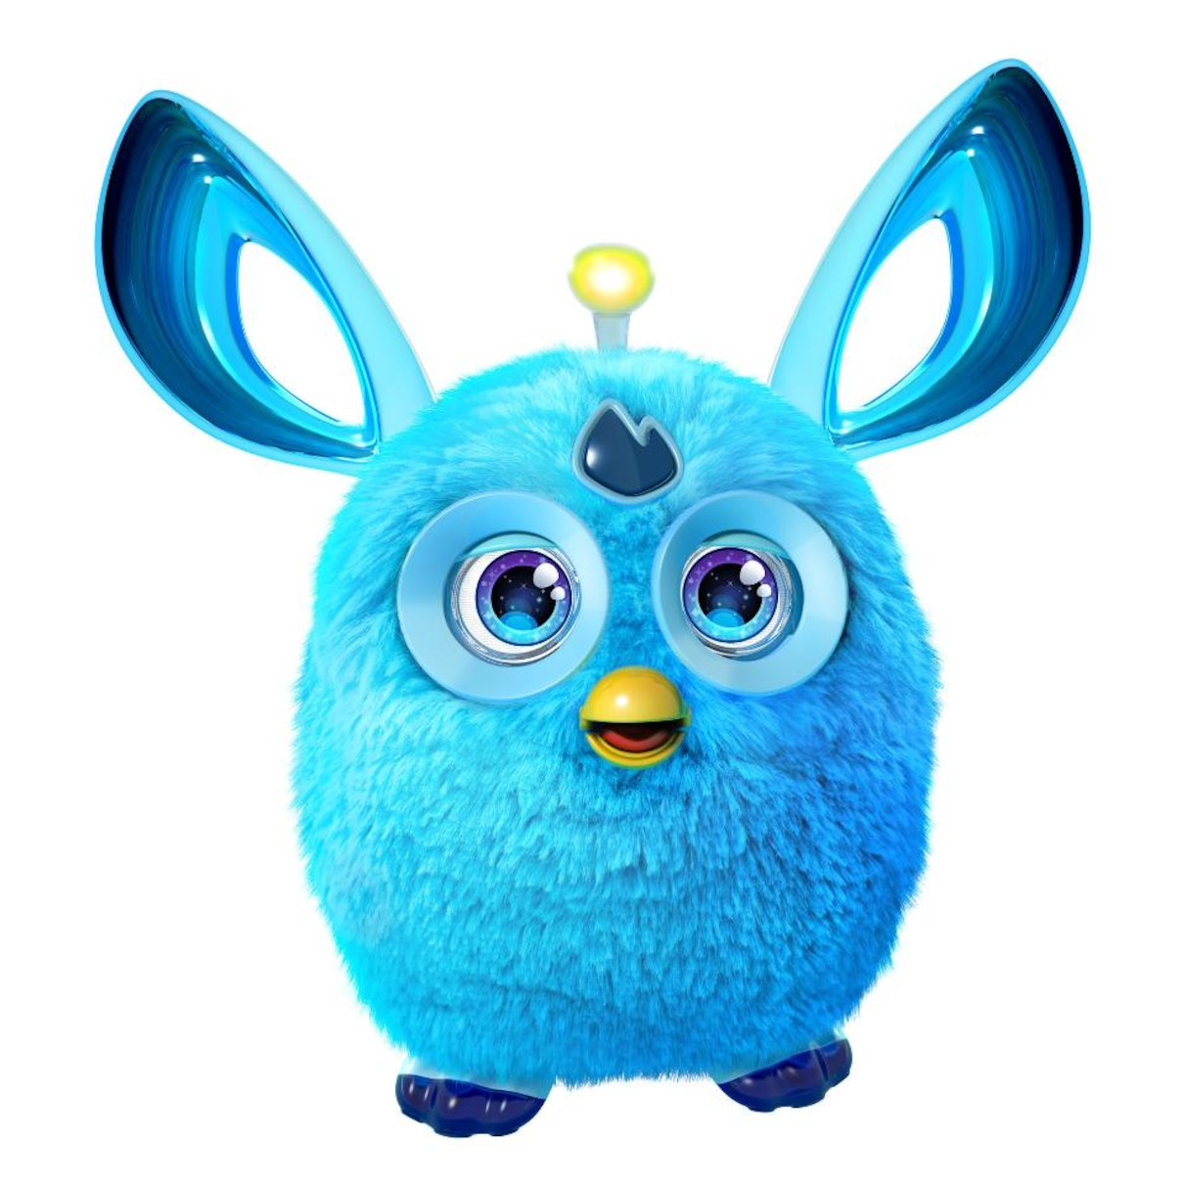

I then designed and created Frimpo. This had a few steps:

Choose Materials:

Went to FabricVille to feel all the furs and choose one. I also settled on foam to line the innards of Frimpo. I chose a purple and blue fur that was very soft to be approachable to children, Frimpo’s main audience. Next I needed something spherical to store Frimpo’s electronics. I settled on a hamster ball as it would be secure enough to mount the arduino and required sensors.

Next I had to learn how to use the Vive Tracker, a small device that allows you track any real world object in VR. this involved printing a 40 page document and learning how to use the various functions, like inputting digital values into Unity.

Choosing sensors for Frimpo was my next task, I went with simple sensors due to my lack of knowledge in the field (this is the first project I’m doing 100% alone) so I settled on two photocells and a strip of velostat. The photocells for Frimpo’s eyes and mouth, and the velostat I fashioned into a pressure sensor.

Lawrence at the Sensor Lab helped me greatly getting my materials attached, teaching me how cut fabric and use the sewing machine. This was really fun and she is really helpful.

**Below is a process of me building Frimpo:**

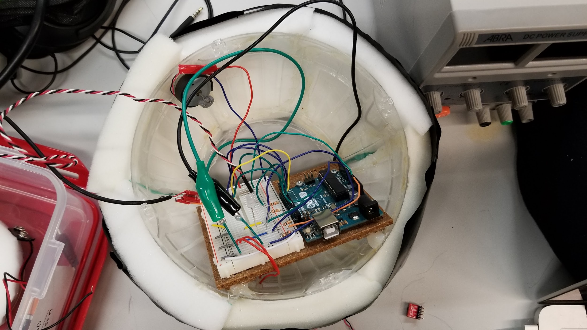Frimpos “Guts”

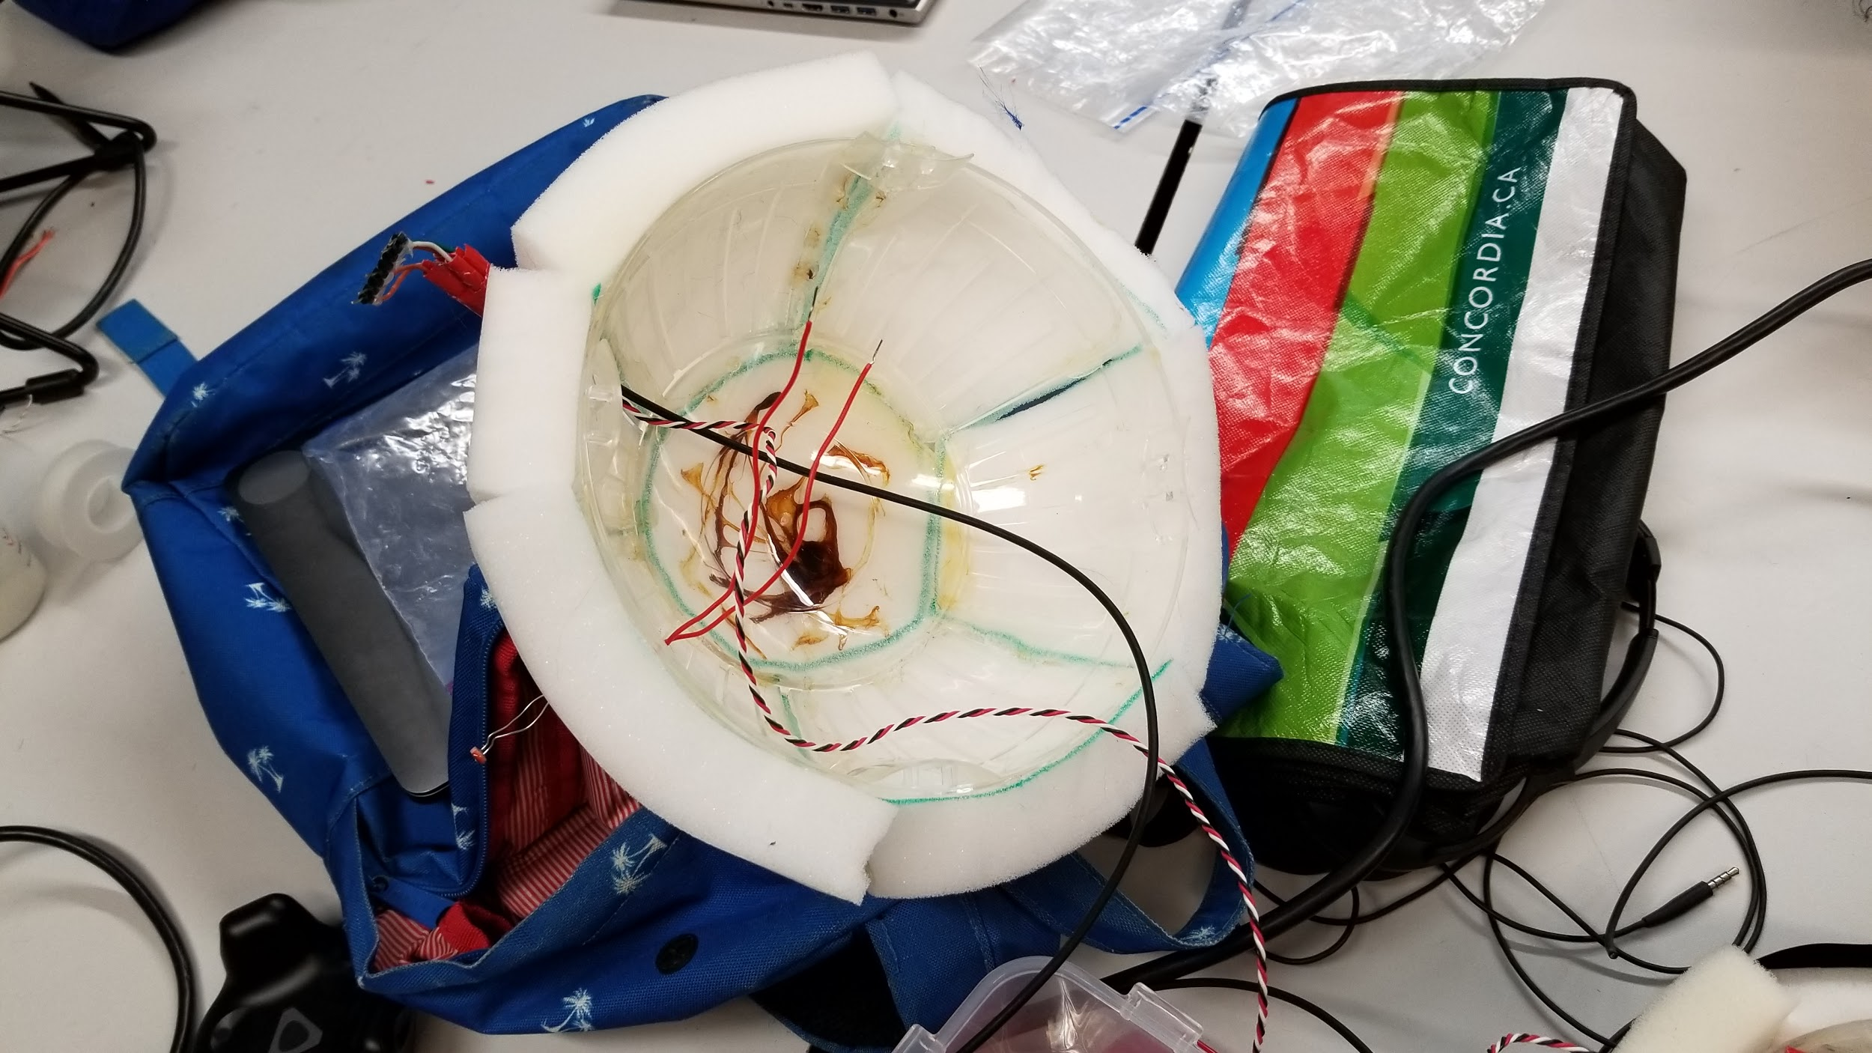Mounting the Tracker on top (wires lead to trackers input pins)

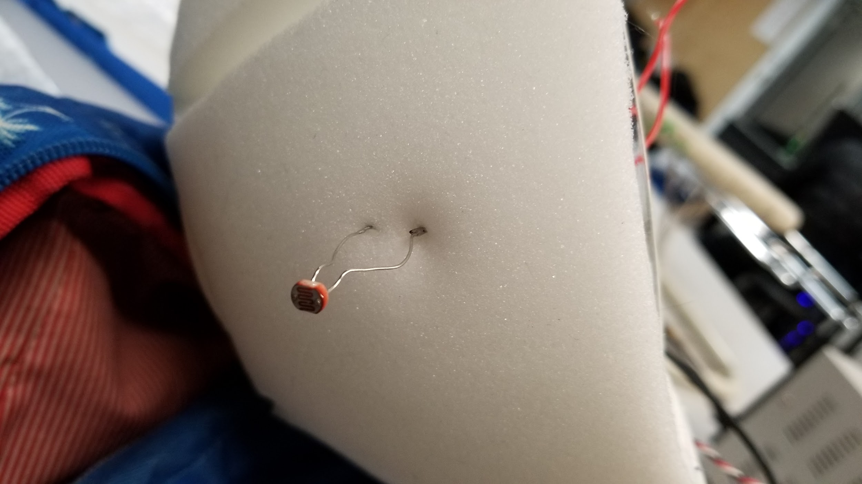Sensor for frimpos eye going through the foam

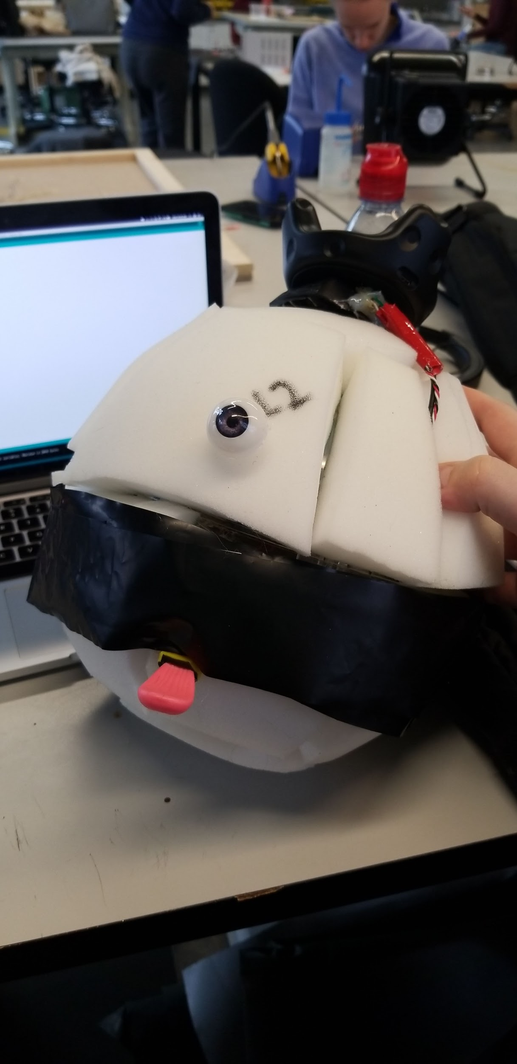Attached Frimpo’s eye & mouth, and then sealed the hamster ball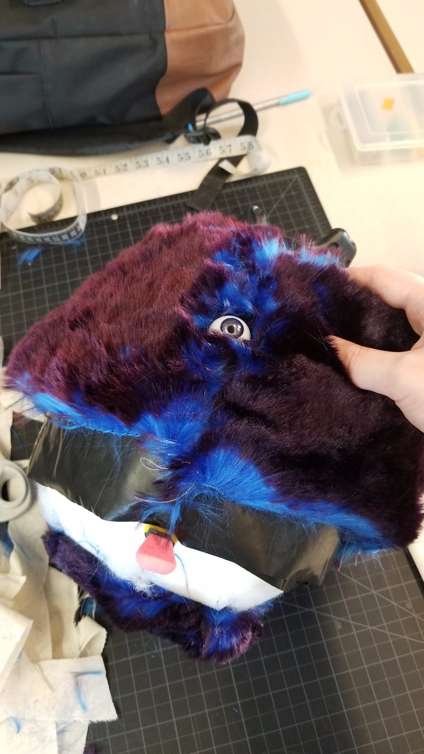Top layer of Fur Added, close to finished! Also set up battery mount

Frimpo is finally finished and he looks great! Below are 5 photos of Frimpo’s finished form.